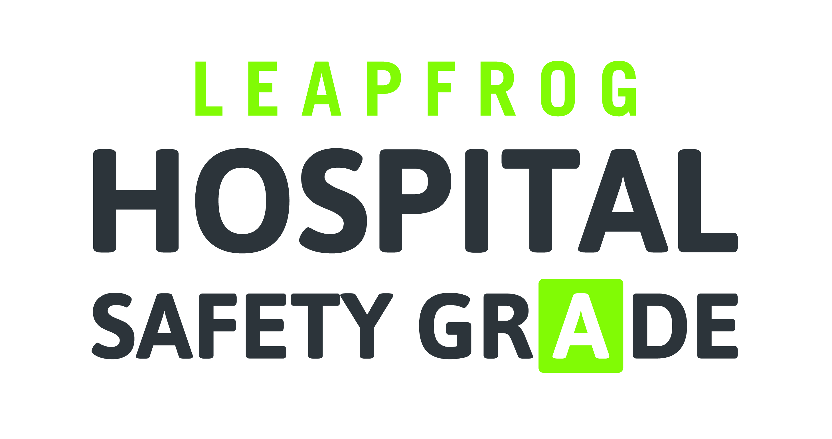

PURCHASER TOOLKIT
Posts for Internal Social Media Platforms (Enterprise Networks)

Short Posts
- Ntl nonprofit The Leapfrog Group grades hospitals on how safe they are for patients. Find out how your hospital scores on safety at www.hospitalsafetygrade.org
- Protect yourself & your loved ones, and check your hospital's Safety Grade www.hospitalsafetygrade.org #patientsafety @LeapfrogGroup
- #PatientSafety should always come first. Choose a safer hospital www.hospitalsafetygrade.org
- Be an empowered patient. Choose a safer hospital w/ www.hospitalsafetygrade.org #patientengagement
- A startling stat: 1/25 patients gets an infection in the hospital—an infection that didn’t have to happen www.hospitalsafetygrade.org
- A startling stat: today alone, 1000 will die from a medical error in a hospital. Learn more at www.hospitalsafetygrade.org
- Consumers need to know about safety & quality when making #healthcare decisions. Start now w/ www.hospitalsafetygrade.org
- Some ppl do more research on what car to buy than what hospital to go to. Change that now www.hospitalsafetygrade.org #patientsafety
- Does your hospital prevent infections & encourage handwashing? Find out www.hospitalsafetygrade.org #InfectionPrevention
- Does your hospital value #patientsafety by supporting strong #healthcare teams? Find out www.hospitalsafetygrade.org
- Does your hospital have protocols in place for preventing med errors? Find out www.hospitalsafetygrade.org
Long Posts
Today alone, more than 1000 people will die because of a preventable hospital error. Make sure you know how to protect yourself and your family by using the @HospitalSafetyGrade from @TheLeapfrogGroup. www.hospitalsafetygrade.org
As many as 440,000 people die every year from preventable errors in hospitals. It’s up to us all to make sure that patient safety is the number one priority at every hospital across the U.S. Start now, and see how well your hospital protects its patients from errors, injuries, accidents, and infections. www.hospitalsafetygrade.org

