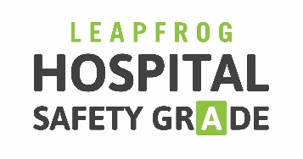

PURCHASER TOOLKIT
Key Talking Points on the Leapfrog Hospital Safety Grade
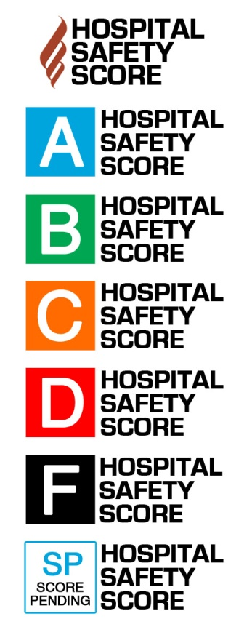

What is the Leapfrog Hospital Safety Grade?
The Leapfrog Hospital Safety Grade is an “A,” “B,” “C,” “D” or “F” assigned to general hospitals in the U.S., rating how safe they are for their patients. The grade uses up to 27 measures including rates of preventable errors, injuries and infections, and whether hospitals have systems in place to prevent them. Grades are updated twice annually, in the fall and spring. The Safety Grades are based on a peer-reviewed methodology, calculated by top patient safety experts and are 100% transparent and free to the public.

Who is The Leapfrog Group?
Founded in 2000 by large employers and other purchasers, The Leapfrog Group is a national nonprofit organization driving the movement for giant leaps forward in the quality and safety of American health care. For nearly 20 years we have collected, analyzed, and published hospital data on safety, quality, and resource use. That means purchasers can find high-value care, and it means real people are empowered with the information they need to make better decisions.

How and why are you involved with The Leapfrog Group?
The Leapfrog Group—and all of the employers like us involved with its mission—seeks to raise public awareness of the safety of hospitals in communities across the country. By grading hospitals on safety performance, Leapfrog empowers our employees and the public to choose the safest hospital. We are proud to stand with Leapfrog on this groundbreaking initiative, and we’re happy to offer our employees the ability to analyze their hospitals’ safety.

We are also very active in our local business coalition, [Insert name of local business coalition on health] that is a Leapfrog Regional Leader. Thanks to the efforts of employers and coalitions like us across the country, this easy-to-use, patient-friendly data is now available. We will continue to advocate for improvements in hospital safety and quality, as well as to encourage that all hospitals publicly disclose information on safety and quality so that you can make the most informed decision on where to seek care.

What is the difference between The Leapfrog Hospital Survey and The Leapfrog Hospital Safety Grade?
The Leapfrog Hospital Survey is an annual voluntary survey in which Leapfrog asks hospitals to report quality and safety data and then publicly reports that information by hospital. The Leapfrog Hospital Safety Grade is a letter grade Leapfrog bi-annually assigns to general hospitals in the United States, whether they report to the Survey or not. If a hospital does not report to the Survey, the Safety Grade uses publicly available data from numerous secondary sources. The majority of data used to calculate the Safety Grade comes from the Centers for Medicare and Medicaid Services.

What should I do if my local hospital didn’t get a good grade on the Leapfrog Hospital Safety Grade?
The Leapfrog Hospital Safety Grade is one tool that you should use in selecting a hospital. It is important to talk with your doctor about what hospital is best for you and your family. Never refuse care in an emergency because of the Leapfrog Hospital Safety Grade. Rather, use the Leapfrog Hospital Safety Grade as a guide for planned events and a research tool for potential emergencies. Leapfrog also offers free guidance and resources on its website for patients and family members to protect themselves during a hospital stay. Those are important no matter what the hospital’s grade is because no hospital is perfectly safe.

How can I make sure my family and I are staying safe in the hospital?
Even when receiving care at an “A” hospital, it is important to stay vigilant and take action to protect yourself. Be prepared for your hospital stay by doing things like researching your hospital in advance, giving your doctors lists of your medications and all your medical records, and following checklists of steps to take in order to stay safe in the hospital. Visit the Leapfrog Hospital Safety Grade website for more tips on staying safe from harm while receiving hospital care.

