PURCHASER TOOLKIT
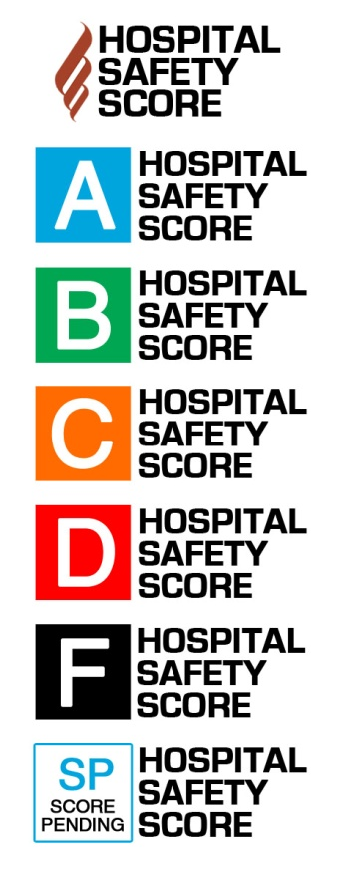
Template Email for Employers to Send to ASCs

[YOUR LETTERHEAD]

[Date]
[Prefix] [First] [Last]
Chief Executive Officer
[Facility Name]
[Street Address]
[City, State, Zip]

Dear [ASC CEO/Administrator Name],
I am writing directly from [Employer] to urge your ASC to complete the Leapfrog ASC Survey. Representing [XX covered lives] in [geographic area], one of the highest priorities for us as an employer is increasing transparency from providers to ensure our employees are receiving the best care and we are achieving value from our investment in health care benefits. As many of our employees now have procedures performed in a same-day surgery environment, it is critical that we have information on the safety and quality of the care you provide. Because there is so little data publicly reported on same-day surgery facilities, we are looking to ASCs to participate in the new Leapfrog ASC Survey. Like their flagship Leapfrog Hospital Survey, the Leapfrog ASC Survey is one of the most effective tools for addressing and reporting key measures of patient safety, quality, and resource use in the outpatient environment.
By submitting a completed Survey, you will receive a customized benchmarking report that shows how you compare to your peers. You can use this data to identify opportunities for improvement and develop a corresponding performance improvement plan. Leapfrog publicly reports ASC Survey Results on its website: ratings.leapfroggroup.org.
Our company uses the data hospitals supply to the Leapfrog Hospital Survey in several ways and we intend to do the same with data submitted to the Leapfrog ASC Survey:
      - List different activities of employer related to Leapfrog reporting

Hundreds of ASCs have submitted the Leapfrog ASC Survey in response to our and other employers’ requests for increased transparency. It is very important to us that your ASC demonstrate a similar commitment to transparency and excellence in quality and safety by completing a Leapfrog ASC Survey.
Thank you once again for your investment in improving the health of our employees.

Sincerely,

[Employer Representative]

