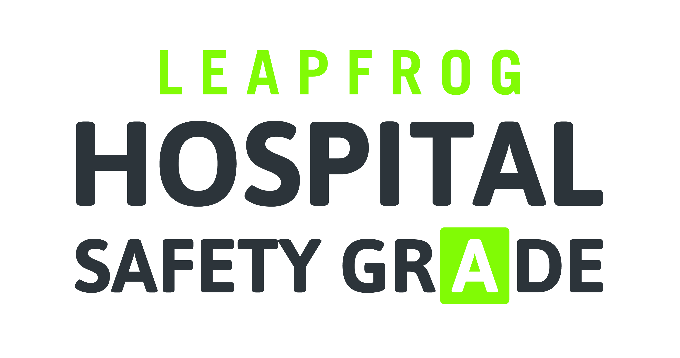

PURCHASER TOOLKIT
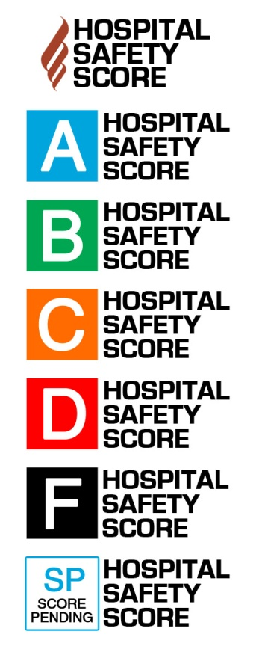
Template Email for Employers to Send to Employees

SHORT VERSION
Dear [Company Name] employees,
Do you know if your local hospital is a safe place to receive care? It is estimated that one in four people admitted to a hospital will be unintentionally harmed during their hospital stay, and over 1,000 people a day will die from errors, injuries, accidents, and infections in hospitals. Most of us don’t think about the importance of choosing a safe hospital until we or our family members are faced with an emergency. And until now, there hasn’t been a lot of easy-to-use information available on hospital safety. Fortunately, a national nonprofit organization called The Leapfrog Group releases the Leapfrog Hospital Safety Grade for over 2,600 hospitals across the country, including [x number] of hospitals here in our area.
Visit www.hospitalsafetygrade.org to check out the Safety Grades of hospitals in [your city/state]. Or, download the Hospital Safety Grade app for FREE on your iPhone, iPad, or Android device. Just search “Hospital Safety Grade” in the app stores.

LONG VERSION
Dear [Company Name] employees,
Do you know if your local hospital is a safe place to receive care? Most of us don’t think about the importance of choosing a safe hospital until we or family members are faced with an emergency. But it is estimated that one in four people admitted to a hospital will be unintentionally harmed during their stay, and that over 1000 people a day die from errors, injuries, accidents, and infections in hospitals.
That’s the bad news, but here’s the good news. A nonprofit organization that we are involved with called The Leapfrog Group releases a Leapfrog Hospital Safety Grade for over 2,600 hospitals across the country, including [x number] of hospitals here in our area. This consumer-friendly tool can help you protect yourself and your loved ones during a hospital stay.
The Leapfrog Hospital Safety Grade rates hospitals on how safe they are for patients. Each A, B, C, D or F score comes from expert analysis of publicly available data. The Leapfrog Group believes that all consumers have a right to know how safe their local hospital is, and should be able to use that information as one important factor in deciding which hospital to go to if they need one.
Visit www.hospitalsafetygrade.org to check out the Safety Grades of hospitals in [your city/state] and other areas where you might have family. Or you can download the Hospital Safety Grade app for free on your iPhone, iPad, or Android device. Just search “Hospital Safety Grade” in the app store.
Of course, if you are in a true emergency, get to the hospital closest to you in order to receive immediate care. But planning ahead—by checking the Safety Grades of local hospitals—can help you make the best decision if an emergency does arise. Also, many times, you can choose a hospital to receive care. Perhaps you’re scheduling a surgery, or are planning on giving birth. The Hospital Safety Grade enables you to pick the hospital that has the best track record in safety. Just enter your zip code, city, or state, and search to see the Safety Grades of hospitals in your area.
Regardless of which hospital you choose, it is important to remain aware and vigilant about the care you are receiving. There are several things you can do to keep yourself or a family member safe while in the hospital. The Hospital Safety Grade website has lots of information on what you can do to stay safe in the hospital.
If you have any questions about selecting the best hospital for you or the importance of safety in a hospital, please feel free to contact your [wellness officers/wellness champions/HR directors] at [email/phone] for more information. [Employer] hopes that you never will need to use a hospital’s services, but in the event you do, we encourage you to utilize the Leapfrog Hospital Safety Grade website and app to choose the safest hospital for your care.
Signature

